Hot Cocoa Mix Gift:
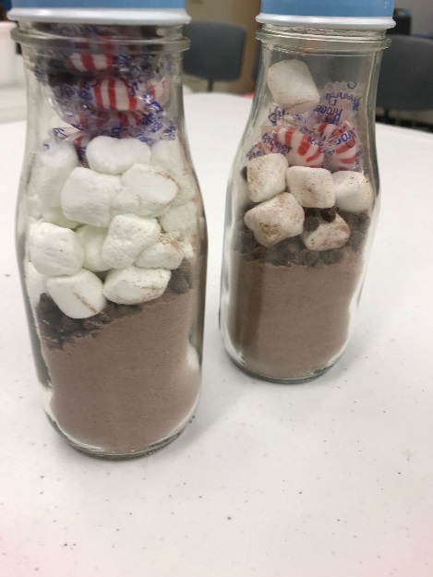
Materials Needed:
- Glass Jar (We use a Starbucks® Frappuccino® Jar)
- Twine
- Gift Tag
- Ziploc bag (optional)
Ingredients:
- Hot Cocoa Mix
- Mini M&M’s®
- Chocolate Chips (Mini)
- Peppermint Swirl Candies
- Marshmallows

What to Do:
- Pour two servings of Hot Cocoa mix into the jar. (Depending on your mix, you’ll require different amounts.)
- Pour 1 Tablespoon of M&M’s and 1 Tablespoon of mini chocolate chips into the jar.
- Put your peppermint candies and ¼ cup of marshmallows into a bag, and carefully squish into the jar.
- Seal up the jar.
- Use twine to attach a gift tag.
- Your mix is ready for gift giving!
Note: If you don’t mind a little mix on your marshmallows and candies, you can leave the bag out.
For an added look, you can paint your caps. Just make sure they dry before you try to seal the jar up!

